# **Image Processing & Enhancement**

## **Overview**

The "Image Processing & Enhancement" project aims to provide a user-friendly web application for performing various image processing operations directly in the browser. This project leverages OpenCV.js, a JavaScript binding for OpenCV, to enable real-time image manipulation without the need for server-side processing.

**Key Features**

* **Upload and Process Images**: Users can upload images from their local devices and apply a variety of image processing techniques.
* **Multiple Operations**: Includes operations such as Gaussian Blur, Median Blur, Sharpen, Edge Detection, Noise Reduction, Brightness Adjustment, Contrast Adjustment, Histogram Equalization, Saturation Adjustment, and Gamma Correction.
* **Interactive Interface**: Simple and intuitive interface with options to adjust intensity for each operation.
* **Immediate Feedback**: Processed images are displayed in real-time on the canvas, allowing users to instantly see the effects of their selected operations.

This project is ideal for developers, researchers, and enthusiasts looking to explore image processing techniques directly within a web browser environment.

## **Getting Started**

# **Prerequisites and Dependencies**

To run the "Image Processing & Enhancementr" project, ensure you have the following prerequisites and dependencies installed:

1. **Web Browser**:
   * Ensure you have a modern web browser that supports HTML5 canvas and JavaScript.
   * Recommended browsers include Google Chrome, Mozilla Firefox, or Microsoft Edge.
2. **OpenCV.js**:

Include the OpenCV.js library in your project. You can use the CDN link provided in your index.html file:  
html  
Copy code  
<script src="https://docs.opencv.org/4.x/opencv.js"></script>

* + This library provides the core image processing functionalities in JavaScript.

1. **Python (Optional for Alternative Implementation)**:
   * If you choose to use the Python alternative implementation provided, ensure you have Python installed on your system (Python 3.x recommended).
   * Required Python packages include tkinter, PIL, opencv-python, and numpy.
2. **Local Web Server (Optional)**:
   * While not mandatory, using a local web server can prevent issues related to browser security restrictions.
   * You can install a simple web server like http-server for Node.js or use Python's built-in http.server.

# **Installation Instructions**

Follow these steps to set up and run the "Image Processing & Enhancement" project on your local machine:

### **1. Clone the Repository**

Clone the GitHub repository to your local machine using Git. Open a terminal and run:

bash

Copy code

git clone https://github.com/Bhushanmv007/Cgi.git

Alternatively, download the repository as a ZIP file and extract it to a local directory.

### **2. Set Up the Project Files**

Navigate into the project directory:

bash

Copy code

cd Cgi

### **3. Configure Environment**

#### **For Browser-Based Implementation:**

* Open the index.html file in a text editor.

Ensure you have an active internet connection to load the OpenCV.js library:  
html  
Copy code  
<script src="https://docs.opencv.org/4.x/opencv.js"></script>

#### **For Python Alternative (Optional):**

* Ensure Python 3.x is installed on your system.

Install necessary Python packages using pip:  
bash  
Copy code  
pip install opencv-python-headless pillow

### **4. Run the Application**

#### **Using a Web Browser:**

* Open index.html file in your preferred web browser (Google Chrome, Mozilla Firefox, etc.).
* Upload an image using the file input field and apply various image processing operations as per the UI instructions.

#### **Using Python Alternative (Optional):**

Run the Python script main.py using Python 3.x:  
bash  
Copy code  
python main.py

* The GUI application will open. Use it to load an image file, apply filters or enhancements, and view the processed image.

### **5. Adjust Browser Settings (if necessary)**

* Ensure your web browser allows local file access to upload images directly from your device.
* Adjust browser settings or run the project on a local web server if you encounter issues related to file access or security restrictions.

### **6. Explore and Customize**

* Explore different image processing operations available in the application.
* Customize the project as per your requirements by modifying HTML, CSS, and JavaScript files in the Cgi directory.

## **Usage**

Explain how to use your application. Include step-by-step instructions or code snippets if necessary.

### **Uploading an Image**

Explain how users can upload an image for processing.

### **Applying Operations**

Describe how users can select and apply different image processing operations.

### **Viewing Results**

Explain how users can view the processed image on the canvas.

## **Operations Available**

List and briefly describe each image processing operation available in your application.

1. **Gaussian Blur**
2. **Median Blur**
3. **Sharpen**
4. **Edge Detection**
5. **Noise Reduction**
6. **Brightness Adjustment**
7. **Contrast Adjustment**
8. **Histogram Equalization**
9. **Saturation Adjustment**
10. **Gamma Correction**

## **Screenshots**

### **Upload Interface**

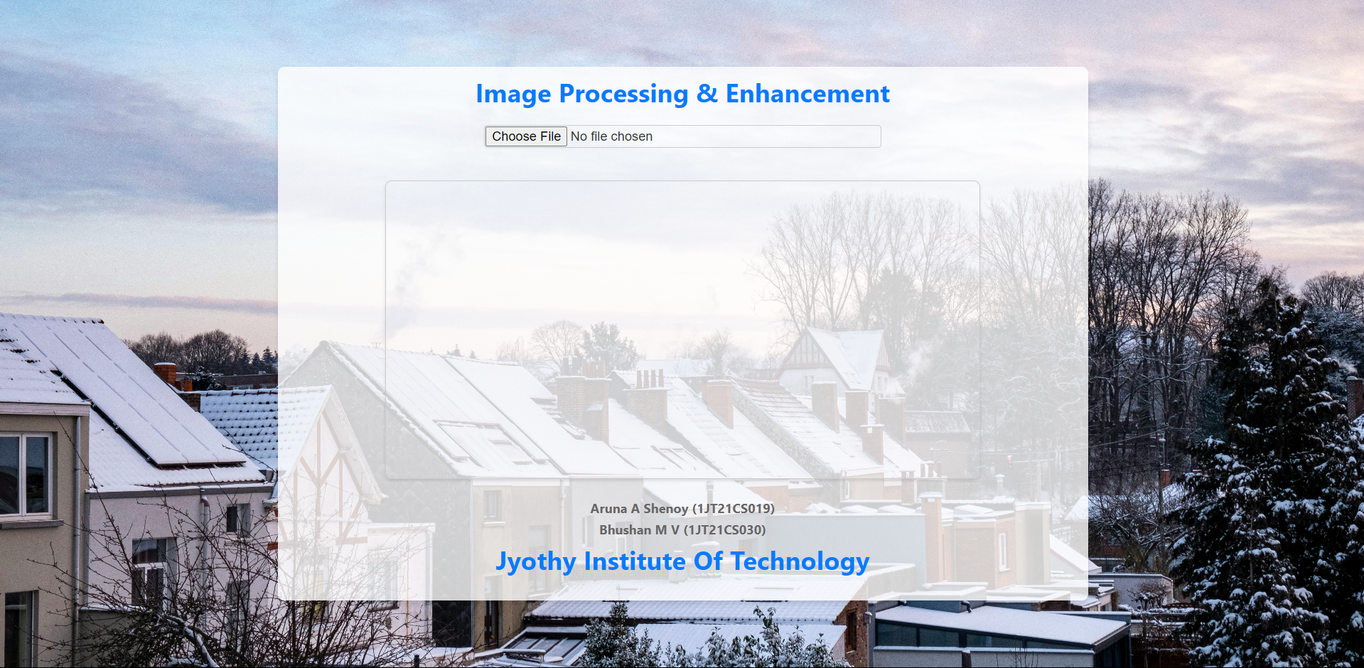

### 

### 

### 

### 

### 

### **Options Selection**

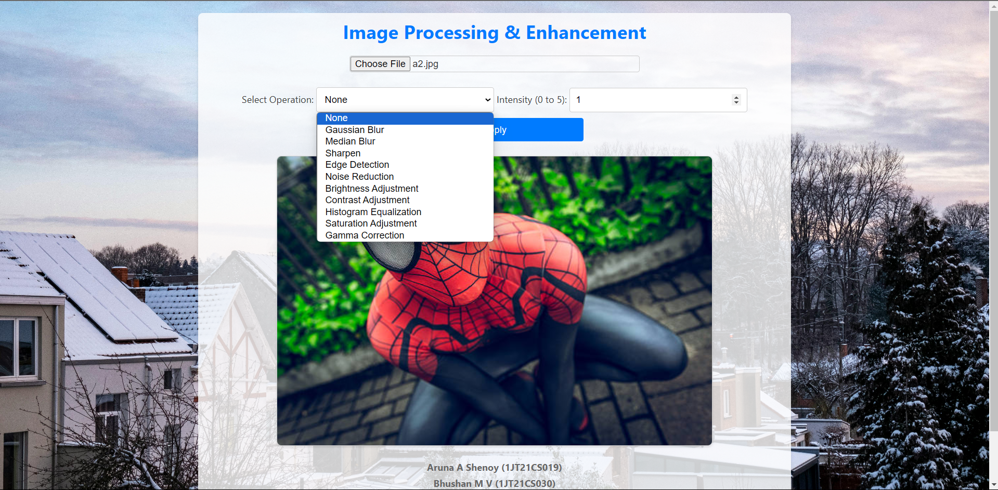

### **Processed Image**

